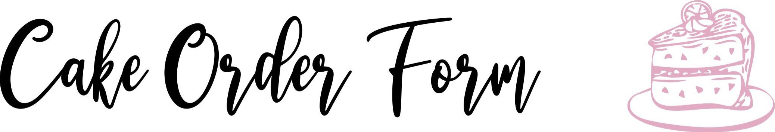

ORDER DATE PROMISE DATE
CUSTOMER INFO
NAME
Phone & Email
FLAVOR
FILLING
ICING
DRAWING SHAPE

Please upload cake inspiration picture

ORDER DETAILS
DELIVERY □  *Fee based on distance  Inquire additional cost prior to placing order.  Local Pick-up □  *Missouri City Shoppe |  | Payment  Cash *only accepted at time order is placed (in person)  ZELLE *FEE FREE  All following platforms incur a 3% transaction fee  Venmo PayPal Cashapp |  | AMOUNT  SUBTOTAL  TAXES  SHIPPING  GRAN DTOTAL
THANK YOU

